**A PROJECT BASED LEARNING**

**REPORT ON**

**“SMART AGRICULTURE”**

SUBMITTED TOWARDS THE

PARTIAL FULFILLMENT OF THE REQUIREMENTS OF **BACHELOR OF ENGINEERING (SE AI & DS)**

**BY**

Ms. Pawar Pournima Chandrashekhar Exam No:S190592032

Ms. Pokale Bharati Mahadev Exam No: S190592034

Ms. Takale Girija Sandeep Exam No: S190592043

Mr. Wadate Vivek Sahebrao Exam No: S190592048

**Under The Guidance of**

Prof. Rucha Agrawal



“Excellence in the field of AI & DS”

**Department of Artificial Intelligence & Data Science**

“Techno-Social Excellence”

**Marathwada MitraMandal's Institute of Technology** Lohgaon, Pune- 411 047

A. Y (2023-24)



“Techno-Social Excellence”

Marathwada Mitramandal’s

Institute of Technology (MMIT)

Lohgaon, Pune- 411 047

“Excellence in the field of AI & DS”

**Department of Artificial Intelligence & Data Science CERTIFICATE**

This is to certify that the Project Entitled

**“SMART AGRICULTURE”**

Ms. Pawar Pournima Chandrashekhar No:S190592032 Ms. Pokale Bharati Mahadev No: S190592034 Ms. Takale Girija Sandeep No: S190592043 Mr. Wadate Vivek Sahebrao No: S190592048 are bonafide work carried out by students under the supervision of Prof.Rucha Agrawal and it is submitted towards the partial fulfilment of the requirement of Bachelor of Engineering (SE AI & DS) Project Based Learning.

Prof.Rucha Agrawal Prof. A.K. Bhise Internal Guide H.O.D Dept. of AI & DS Dept. of AI & DS

**Abstract**

The project is an Internet of Things-based smart agriculture. The model's primary goal will be to detect pests in crops before they cause any critical damages. In this context, this project aims to develop a pest detection system using IoT techniques. The system will be designed to detect pests in crops through a combination of some sensors and arduino.The farmer can then take appropriate action, such as applying pesticide or removing infected crops.This will have an efficient outcome.

**INDEX**

|  |  |  |  |
| --- | --- | --- | --- |
| **S. No** | **TOPIC NAME** | | **PAGE NO** |
| 1 | INTRODUCTION | | 1 |
| 2 | OBJECTIVES OF SYSTEM | | 2 |
| 3 | LITERATURE SURVEY | | 3 |
| 4 | MOTIVATION | | 4 |
| 5 | PROBLEM STATEMENT | | 5 |
| 6 | SYSTEM ARCHITECTURE | | 6 |
| 7 | ALGORITHMS USED | | 7 |
| 8 | HARDWARE REQUIREMENT | | 8 |
| 9 | SOFTWARE REQUIREMENT | | 9 |
| 10 | FUTURE SCOPE | 10 | |
| 11 | CONCLUSION | 11 | |
| 12 | REFERENCES | 12 | |

**LIST OF FIGURES**

|  |  |  |
| --- | --- | --- |
| **S.**  **No** | **TOPIC NAME** | **PAGE** |
| 1 | System Architecture | 6 |
| 2 | Use case Diagram | 12 |

**SMART AGRICULTURE**

**Introduction:**

* Crop diseases and insect pests, which are characterized by their high diversity, serious impacts, and localized outbreaks, can cause severe agricultural losses.
* Globally, 20%–40% of crop plant yields are lost annually because of the incidence of crop pests and diseases
* Changes in the global climate and farming systems have led to changes in the incidence of agricultural diseases and insect pests.
* Pesticides are commonly used to control diseases and insect pests in agriculture because they are highly and rapidly effective and allow agricultural producers to increase crop yields.

-Department of AI & DS, MMIT, Lohgaon, Pune 47

**Page no:1**

**Objective:**

-Classification accuracy of different guava plant diseases in real-world scenarios.

-Identify pest and Monitor Progress.

-Cost Effective model.

-Reduce the unnecessary use of pesticides.

­­-Reducing Manpower.

**-** Department of AI & DS, MMIT, Lohgaon, Pune 47

**Page no:2**

Literature survey:-

|  |  |  |  |
| --- | --- | --- | --- |
| Sr. No | Title of the Paper | Year | Remarks |
| 1 | Artificial Intelligence Technology in the Agricultural Sector: A Systematic Literature Review | 2022 | To Improve the Productivity of Farms and Solve Some Agricultural Problems. |
| 2 | Role of Artificial Intelligence in Agriculture: An Analysis and Advancements With Focus on Plant Diseases | 2023 | In Manual Process, Detection of Plant diseases is almost impossible so by using AI techniques plant diseases can be detected. |
| 3 | A Lightweight Deep Learning  Framework for Crop Pest Detection  and Classification | 2023 | The results indicated that our system could reliably localize and categorize  pests of various types, even in the context of complicated backgrounds and fluctuations in different pest forms, hues,dimensions, positions, and luminance. |
| 4 | An Early and Smart Detection of Corn Plant Leaf Diseases Using IoT and Deep Learning Multi-Models | 2024 | To develop a multi-model network with the fusion of multi-contextual networks that is automatically exploited with the CNN strategies. |

Department of AI & DS, MMIT, Lohgaon, Pune 47

**Page no:3**

**Motivation:**

* One of the most significant risks impacting crops is pests, which substantially decrease food production.
* Further, prompt and precise recognition of pests can help harvesters save damage and enhance the quality of crops by enabling them to take appropriate preventive action.
* Advanced technical technologies in agriculture are urgently required to detect pests in their early stages and prevent the widespread application of harmful pesticides

Department of AI & DS, MMIT, Lohgaon, Pune 47

**Page no:4**

**Problem Statement:**

To develop a device that will help in pest detection of guava plant which will increase

its agricultural production.

**-** Department of AI & DS, MMIT, Lohgaon, Pune 47

**Page no:5**

**System Architecture:**

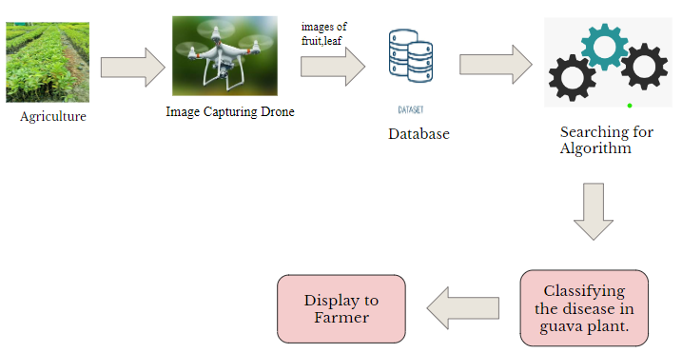

**-** Department of AI & DS, MMIT, Lohgaon, Pune 47 **Page no:6**

**Algorithm Used:**

* Object Detection
* Semantic Segmentation
* K-means algorithm
* Watershed algorithm
* Image processing algorithm
* Image analysis algorithm

Department of AI & DS, MMIT, Lohgaon, Pune 47  **Page no:7 Hardware Requirement:**

1)Drones

2)Sensors :-

**\*** RGB Sensor

**\*** Soil Sensor

**\*** IR Sensor

**\*** Fluorescence Senso **\*** Motion Sensor

**-**Department of AI & DS, MMIT, Lohgaon, Pune 47 **Page no:8**

**Software Requirement:**

1)Computer System :-

Operating System : Ubuntu

Programming Language : Python

RAM : 4 GB (min)

Hard Disk : 50 GB

- Department of AI & DS, MMIT, Lohgaon, Pune 47

**Page no:9**

**Future Scope:**

Plan to combine several image classification methods of multiple plants with the present system to realize accurate disease identification and integration with the intelligent plant protection devices based on the classification results.

**-** Department of AI & DS, MMIT, Lohgaon, Pune 47

**Page no:10**

**Conclusion:**

We developed a system for prevention and control of Guava plant diseases.

The system controls diseases and pests effectively with no adverse effects on the normal growth of the crop.

It greatly reduces the amount of chemical pesticides used, which significantly decreases the costs of agrochemicals and labor.

This work provides a reference for development of intelligent equipment for the prevention and control of diseases and insect pests using physical control methods.

**Use case diagram:**

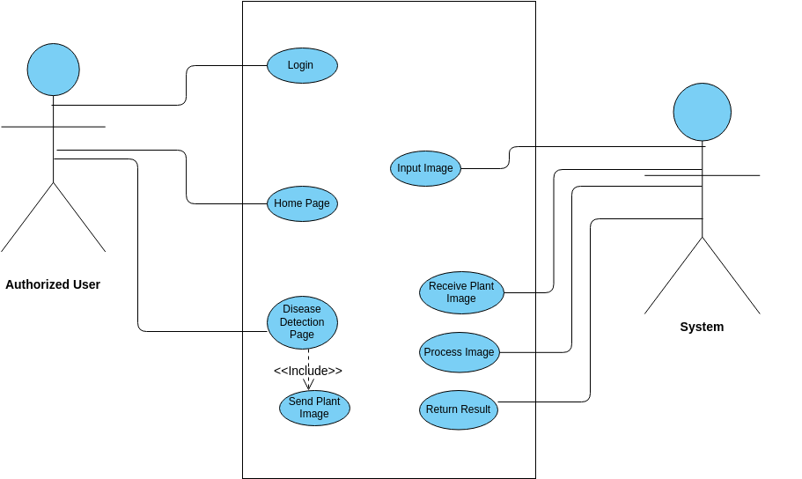

**-**Department of AI & DS, MMIT, Lohgaon, Pune 47

**Page no:11**

**References:**

* ERSIN ELBASI , NOUR MOSTAFA , ZAKWAN ALARNAOUT,AYMEN I. ZREIKAT, ELDA CINA, GREESHMA VARGHESE, AHMED SHDEFAT ,AHMET E. TOPCU, WIEM ABDELBAKI,SHINU MATHEW, AND CHAMSEDDINE ZAKI-”Artificial Intelligence Technology in the Agricultural Sector: A Systematic-Literature Review”
* FAROOQ ALI 1, HUMA QAYYUM 1, AND MUHAMMAD JAVED IQBAL 2,”Faster-PestNet: A Lightweight Deep Learning Framework for Crop Pest Detection and Classification .”
* RUBINA RASHID 1, WAQAR ASLAM 2, ROMANA AZIZ3, AND GHADAH ALDEHIM3,”An Early and Smart Detection of Corn Plant Leaf Diseases Using IoT and Deep Learning Multi-Models.”

**-** Department of AI & DS, MMIT, Lohgaon, Pune 47

**Page no:12**